Joel Atkinson
December 6, 2025
CSD420 Advanced Java Programming
Assignment 9.2

Screenshot of CreateTable.java running and connected to database:
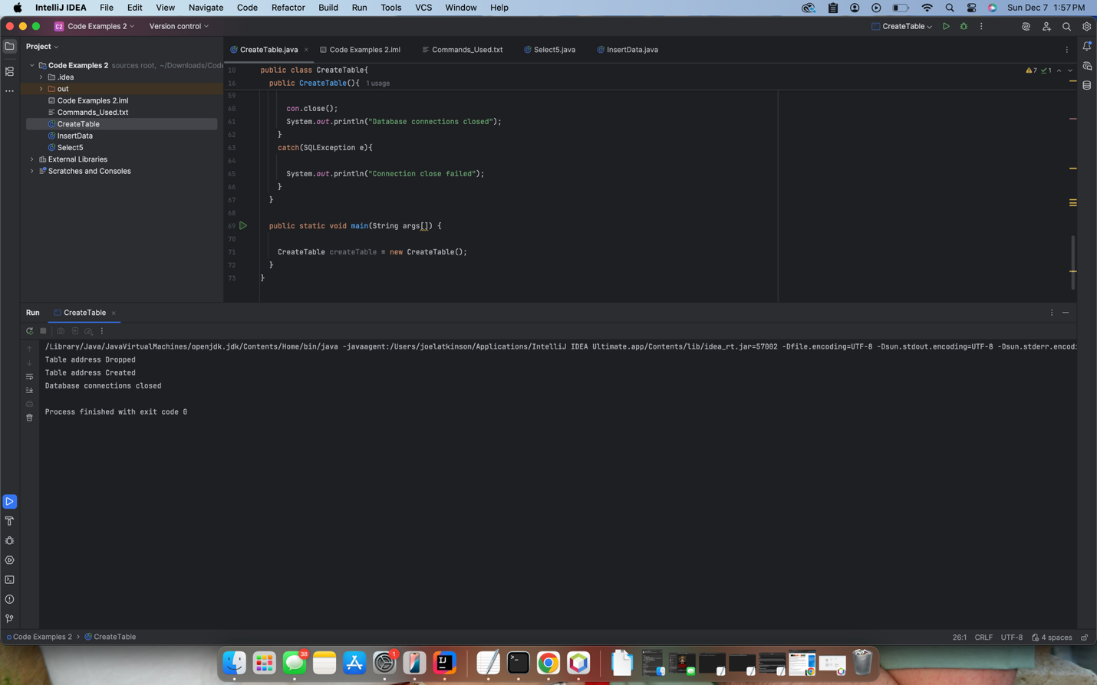

Screenshot of InsertData.java connected and running:
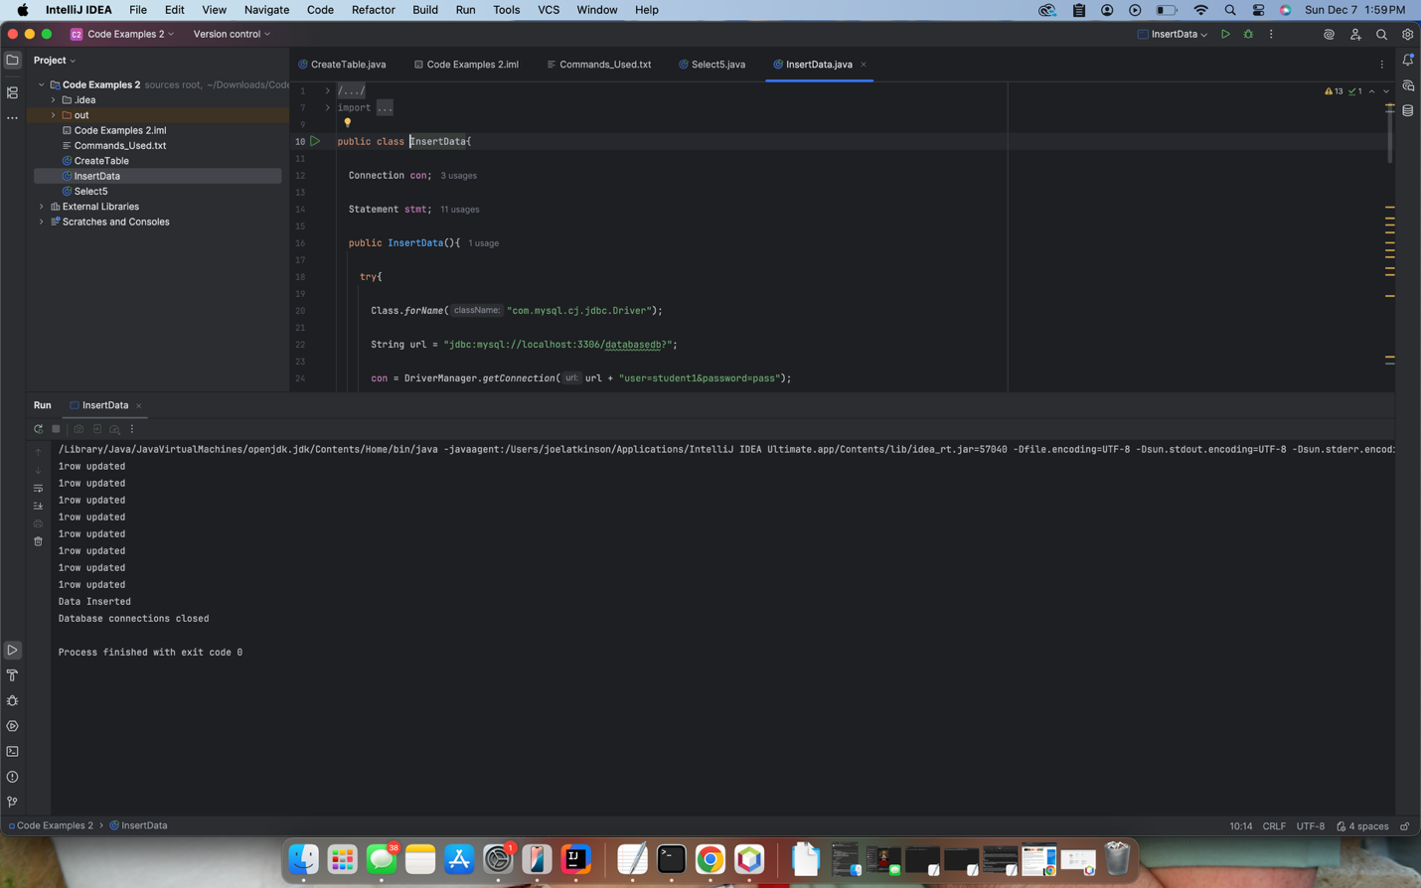
Screenshots of Select5.java running and connected:
